**Lab 2 – Spectrometer Spectral Calibration**

Yuval Levental, Group 4RIT Center for Imaging Science, 54 Lomb Memorial Drive Rochester, NY 14623

**ABSTRACT**

This lab is about spectral calibration of a hand held point spectrometer. This is done through measuring sharp spectral lines with a spectrometer emitted by an Argon (Ar) lamp and a Mercury-Neon (Hg(Ne)) lamp. To calibrate, the relationship between the pixel number and wavelength is determined using an n-degree polynomial. The USB 650 spectrometer is used, and OceanView software is used to measure the output readings.1

**Keywords:** Calibration, spectral lines, polynomial, Argon, Mercury-Neon.

1. **INTRODUCTION**

While the spectrometer has been initially calibrated, the positioning of the light on the detector array may drift, or undergo a spectral shift, as a function of time and environmental effects. The Ar and Hg(Ne) lamp are used to check the calibration, as they emit sharp lines on the 300 – 1000 nm wavelengths.

After the intensities from various wavelengths are collected, three equations which map the pixel index, or detector number, to the wavelength are computed using a MATLAB program in this lab. Those equation models are linear, quadratic, and a polynomial of order 3.

1. **PROCEDURES**

The USB 650 is plugged into the computer and the OceanView software is launched. The fiber optic probe is connected to measure the intensities and wavelengths. The argon pencil lamp is inserted into the Fiber Optic Accessory/SMA Adapter, and the lamp power supply is set to 10 mA. It is important to not look at the sources when they are turned on. The room light is turned off.

The Automatic integration button is selected every once in a while to adjust the integration time for maximum SNR. The emission lines should be as sharp and peaked as possible, so the Boxcar width should not be used. Two-three scans should be averaged to obtain good SNR. The data is paused, and the argon lamp is turned off. The data is saved as a text file. The process is repeated with the Hg(Ne) lamp, with the power supply set to 18 mA. After the data is collected and the lamp cools down, the lamp is removed and a dark noise measurement is taken with the fiber optic probe by itself.

1. **ANALYSIS AND RESULTS**

The data for the Ar and Hg(Ne) lamps for this report was provided by the lab TA. The maximum data point for each wavelength was obtained using the max() function in Google Sheets, as the dark spectrum data was already subtracted off. The top 15 relative intensities from both lamps were identified and categorized in Table 2 from lowest to highest. Additionally, for those intensities, the recorded USB650 wavelengths and their respective true wavelengths from the provided specifications sheet1 were categorized in Table 2. The pixel numbers were calculated as USB650 Wave – 349, because the pixel range is from 1 to 651. Finally, the True Wave – USB650 Wave values were calculated and recorded in Table 2.

The plots of the Ar data, Hg(Ne) data, and combined data are Figures 1-3 respectively. The plot containing the true wavelength vs the USB650 wavelength is Figure 4. The slope of this plot is approximately equal to 1, meaning that the True and USB650 values are very similar. The plots and models for linear, quadratic, and 3rd order polynomial are Figures 5-7 respectively, which are performed in MATLAB.2,3 The linear approximation is the best one, because the coefficients are the most significant overall.

Linear coefficients: α1 = 0.9999, b = 348.9241

Quadradic coefficients: α2 = 0, α1 = 0.9938, b = 349.5356

3rd order polynomial coefficients: α3 = 0, α2 = 0, α1 = 0.9876, b = 349.8576

The average spectral difference was calculated by taking the mean of the True Wave – USB650 values. It is equal to -0.099 nm. The average residuals are calculated using the MATLAB polyfit function error estimates.2 They are 2.7056, 2.6132, and 2.6078 for the Linear, Quadratic, and the 3rd order respectively. The standard error is calculated as the average of the MATLAB polyval error estimate outputs. They are 0.7985, 0.8259, and 0.8836 for the Linear, Quadratic, and the 3rd order respectively.3

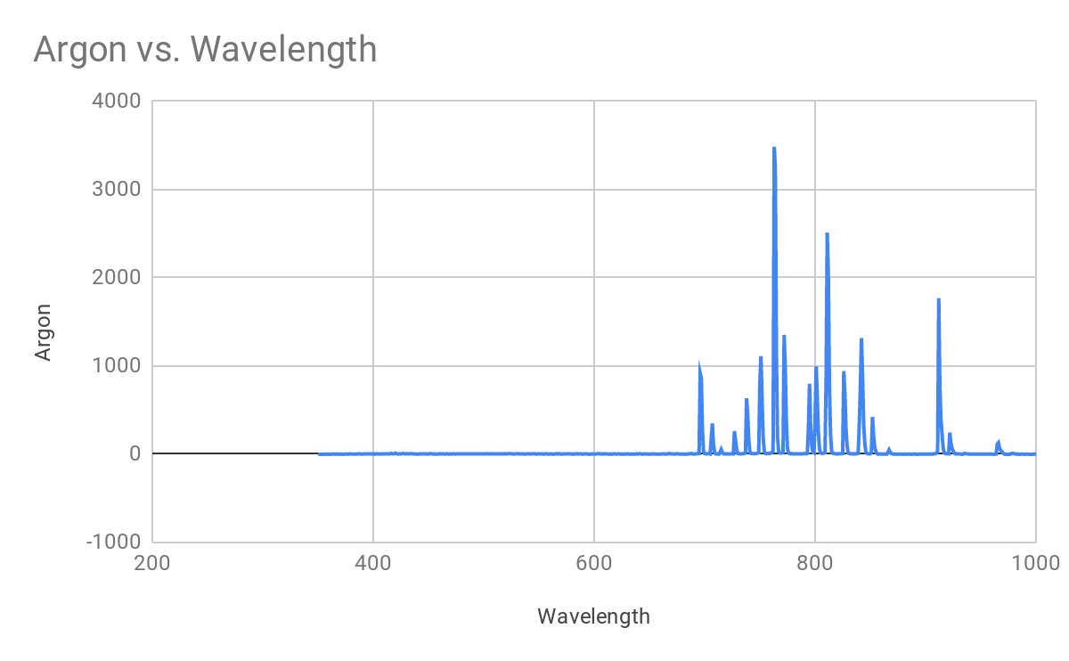

Figure 1. Intensity of Argon in rel vs Wavelength in nm

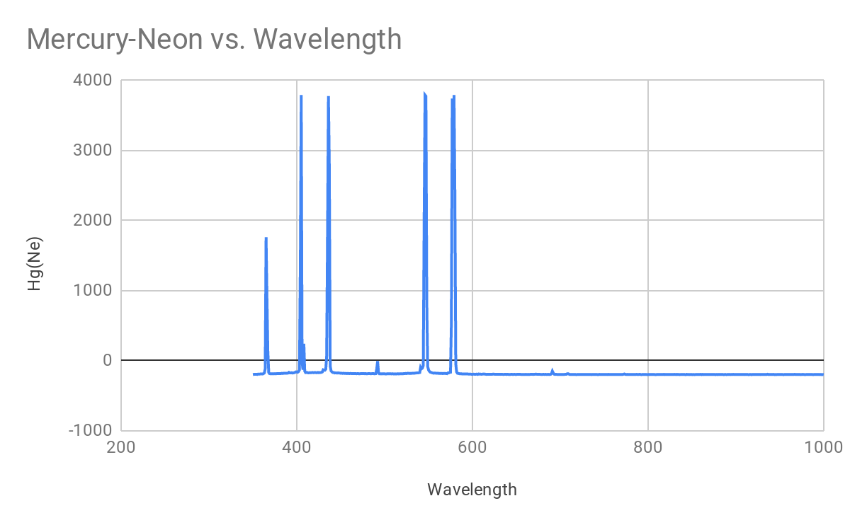

Figure 2. Intensity of Mercury-Neon in rel vs Wavelength in nm

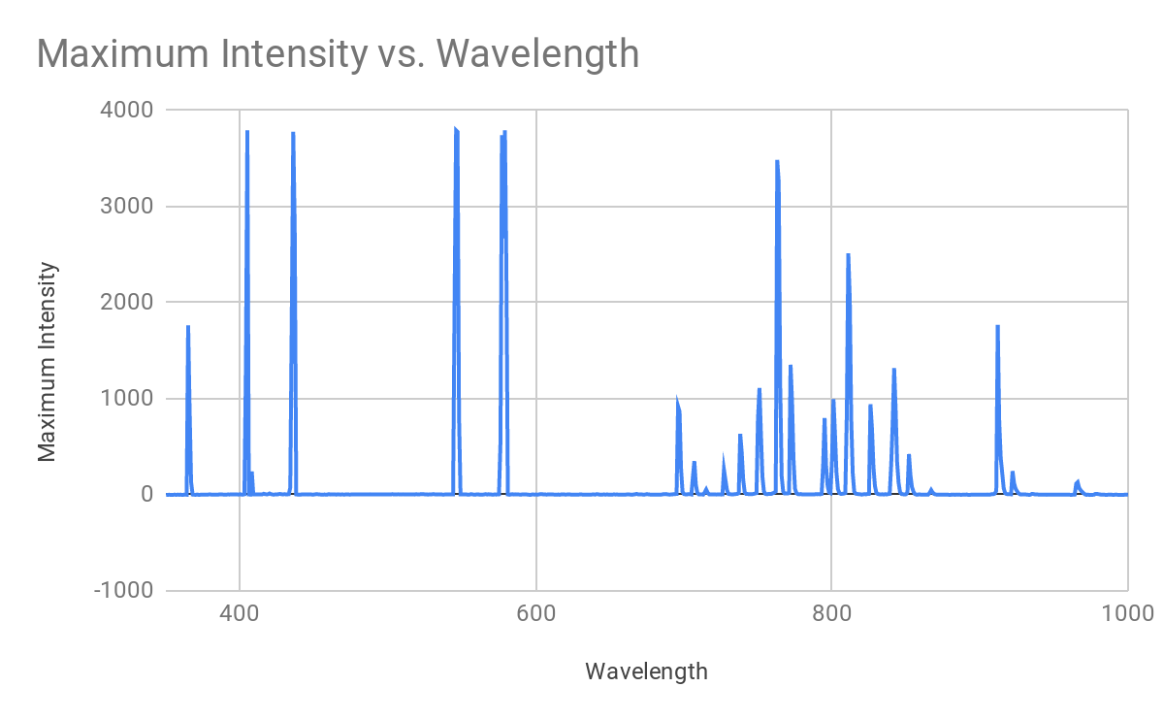

Figure 3. Maximum intensity in rel vs Wavelength in nm

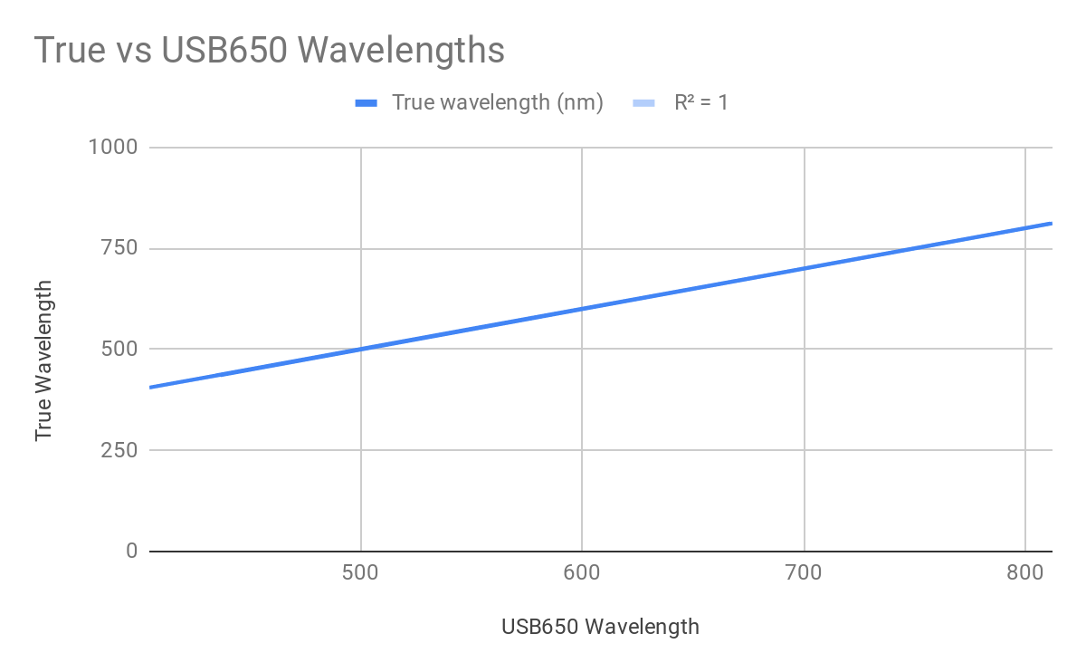

Figure 4. True vs USB650 Wavelengths in nm

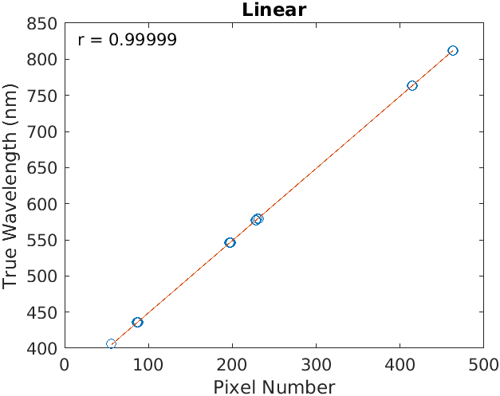

Figure 5. Linear Plot and Model

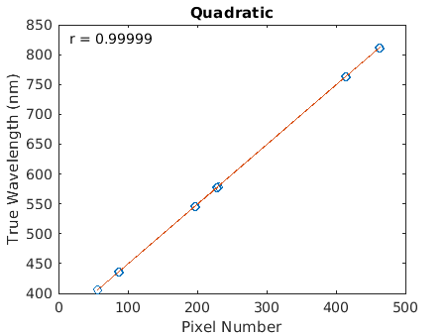

Figure 6. Quadratic Plot and Model

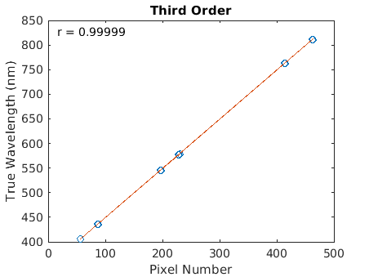

Figure 7. Third order Plot and Model

1. **CONCLUSIONS**

In conclusion, the overall purpose of this lab was to learn how to calibrate a spectrometer using best fit polynomial equations. Data measurement was done in a lab to find relative intensities and wavelengths. The strongest true wavelengths were compared to their respective pixel numbers by using a linear, quadratic, and a 3rd order equation as models. MATLAB programming was highly utilized for analyzing the data. The best model is the linear model, as the coefficients are most significant in value and the standard error is lowest by far. The spectrometer is calibrated well, and errors in the data could have come from an improper lab setting.

**APPENDIX A. MATERIALS, RAW DATA, AND MATLAB CODE**

Table 1. Materials needed for the lab.

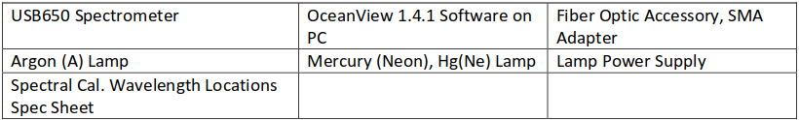

Table 2. Raw Data

|  |  |  |  |  |
| --- | --- | --- | --- | --- |
| True wavelength (nm) | USB650 Wavelength (nm) | Pixel Number | Relative Intensity | Difference |
| 435.84 | 435 | 86 | 1856.09 | 0.84 |
| 546.07 | 545 | 196 | 2027.63 | 1.07 |
| 811.53 | 812 | 463 | 2050.56 | -0.47 |
| 579.07 | 580 | 231 | 2356.14 | -0.93 |
| 811.53 | 811 | 462 | 2512.82 | 0.53 |
| 576.96 | 578 | 229 | 2668.22 | -1.04 |
| 435.84 | 437 | 88 | 2779.42 | -1.16 |
| 763.51 | 764 | 415 | 3252.67 | -0.49 |
| 763.51 | 763 | 414 | 3485.84 | 0.51 |
| 576.96 | 577 | 228 | 3742.18 | -0.04 |
| 546.07 | 547 | 198 | 3776.63 | -0.93 |
| 435.84 | 436 | 87 | 3779.49 | -0.16 |
| 405.65 | 405 | 56 | 3792.57 | 0.65 |
| 546.07 | 546 | 197 | 3792.57 | 0.07 |
| 579.07 | 579 | 230 | 3792.57 | 0.07 |

%{

This MATLAB program is to determine whether a spectrometer is calibrated

using best fit equations.

%}

x = [86, 196, 463, 231, 462, 229, 88, 415, 414, 228, 198, 87, 56, 197, 230]; %Pixel Numbers

y = [435.84, 546.07, 811.53, 579.07, 811.53, 576.96, 435.84, 763.51, 763.51, 576.96, 546.07, 435.84, 405.65, 546.07, 579.07]; %True Wavelengths

str=['r = ',num2str(corr2(x,y))] %correlation coefficient

[p1,S1] = polyfit(x,y,1); %Generate linear coefficients (p1) and average residuals (S1)

[p2,S2] = polyfit(x,y,2); %Generate quadratic coefficients (p2) and average residuals (S2)

[p3,S3] = polyfit(x,y,3); %Generate third order coefficients (p3) and average residuals (S3)

%Generate linear model (y1) and linear standard error (d1)

[y1, d1] = polyval(p1,x,S1);

figure

plot(x,y,'o')

hold on

plot(x,y1)

text(0.03,.95,str,'Units','normalized')

title('Linear')

xlabel('Pixel Number')

ylabel('True Wavelength (nm)')

hold off

%Generate quadratic model (y2) and quadratic standard error (d2)

[y2, d2] = polyval(p2,x,S2);

figure

plot(x,y,'o')

hold on

plot(x,y2)

text(0.03,.95,str,'Units','normalized')

title('Quadratic')

xlabel('Pixel Number')

ylabel('True Wavelength (nm)')

hold off

%Generate third order model (y1) and third order standard error (d1)

[y3, d3] = polyval(p3,x,S3);

figure

plot(x,y,'o')

hold on

plot(x,y3)

text(0.03,.95,str,'Units','normalized')

title('Third Order')

xlabel('Pixel Number')

ylabel('True Wavelength (nm)')

hold off

**REFERENCES**

1. Bachmann, C. and Hughes, E., “Spectrometer Spectral Calibration”, Rochester Institute of Technology (2019).
2. MathWorks®, (2019). Polynomial curve fitting (polyfit) (R2019b). Retrieved September 29, 2019 from https://www.mathworks.com/help/matlab/ref/polyfit.html
3. MathWorks®, (2019). Polynomial evaluation (polyval) (R2019b). Retrieved September 29, 2019 from https://www.mathworks.com/help/matlab/ref/polyfit.html